
MARKING SCHEME FOR ANSWERS TO THE THEORETICAL QUESTION II

Professor Delia DAVIDESCU, National Department of Evaluation and Examination–Ministry of Education and Research- Bucharest, Romania
Part | MARKING SCHEME - THE THEORETICAL QUESTION II - DIFFERENT  KIND OF OSCILLATION | Total  Scores
II.a. | For:  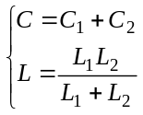 0.2p  the impedance of the circuit 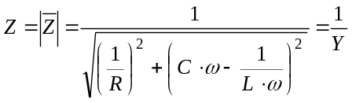 0.2p  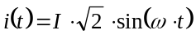 0.2p  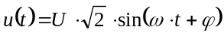 0.2p  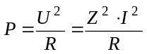 0.1p  the maximal active power is realized for the maximum value of the impedance that is the minimal value of the admittance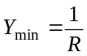 . 0.2p  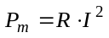 0.2p  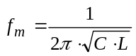 0.2p  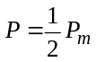 0.1p  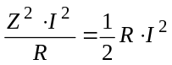 0.1p  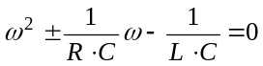 0.2p  the pulsation of the current ensuring an active power at half of the maximum power 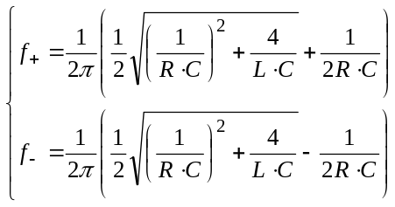 0.2p  the bandwidth of the circuit 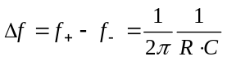 0.1p  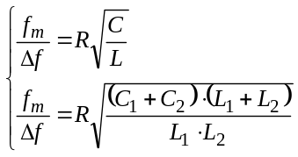 0.2p  final result: 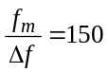 0.1p | 2.5 points
II.b. | 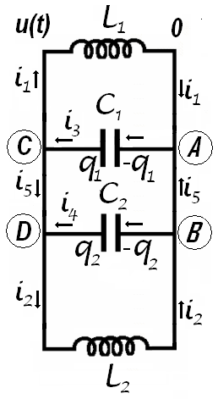  For:  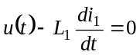 0.1p  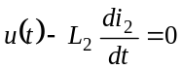 0.1p  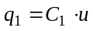 0.1p  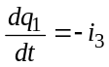 0.1p  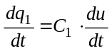 0.1p  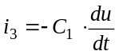 0.1p  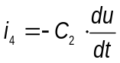 0.1p  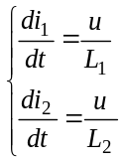 0.2p  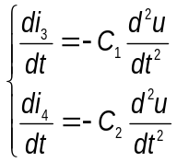 0.2p  the Kirchhoff rule of the currents for the point 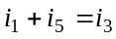 0.1p  the Kirchhoff rule of the currents for the point  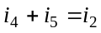 0.1p  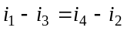 0.1p  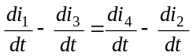 0.1p  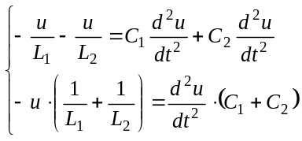 0,2p  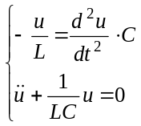 0,2p  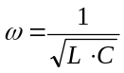 0,2p  final result: 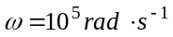; 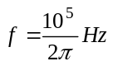 0.1p | 2.2  points
II.c. | For:  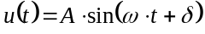 0.1p  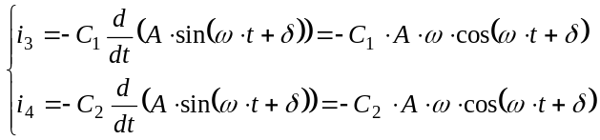 0.2p  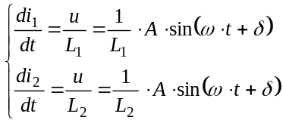 0.2p  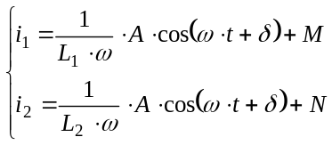 0.2p  Observation: in the expression above,, 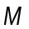, and are constants that must be determined using initially conditions (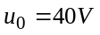, 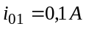, 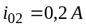)  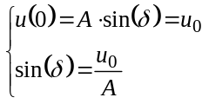 0.1p  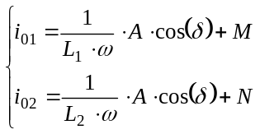 0.2p  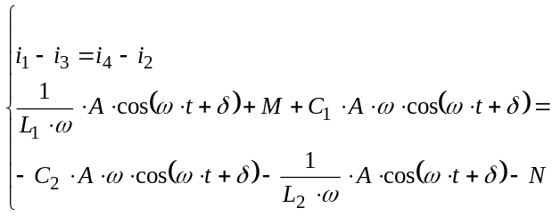 0.2p  Observation: an identity as 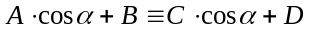is valuable for any value of the argument only if 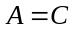and  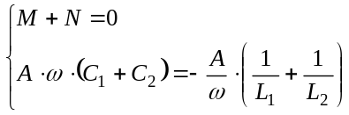 0.1p  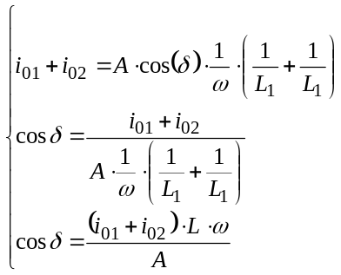 0.2p  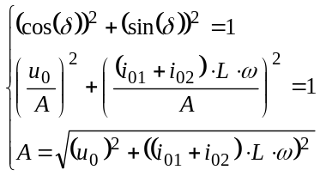 0.1p  the numerical value of the electrical tension on the jacks of the circuit 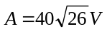 0.1p  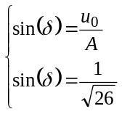 0.1p  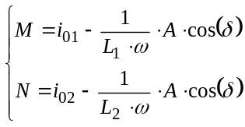 0.1p  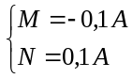 0.1p  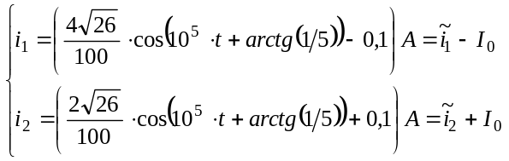 0.2p  Observation: the currents through the coils are the superposition of sinusoidal currents having different amplitudes and a direct current passing only through the coils.  the direct current 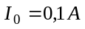 0.1p  the alternative currents through the coils 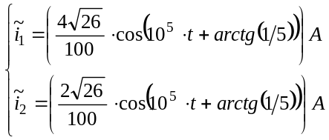 0.2p  the currents through the capacitors  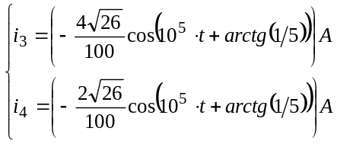 0,2p  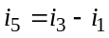 0.1p  final result: 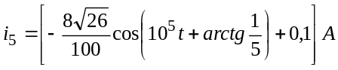 0.2p | 3.0  points
II.d. | For:  the amplitude of the current through the inductance  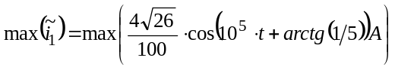 0.2p  final result: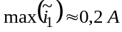 0.1p | 0.3  points
Total score theoretical question III |  | 8.0  points
Professor Adrian S.DAFINEI,PhD, Faculty of Physics – University of Bucharest, Romania

